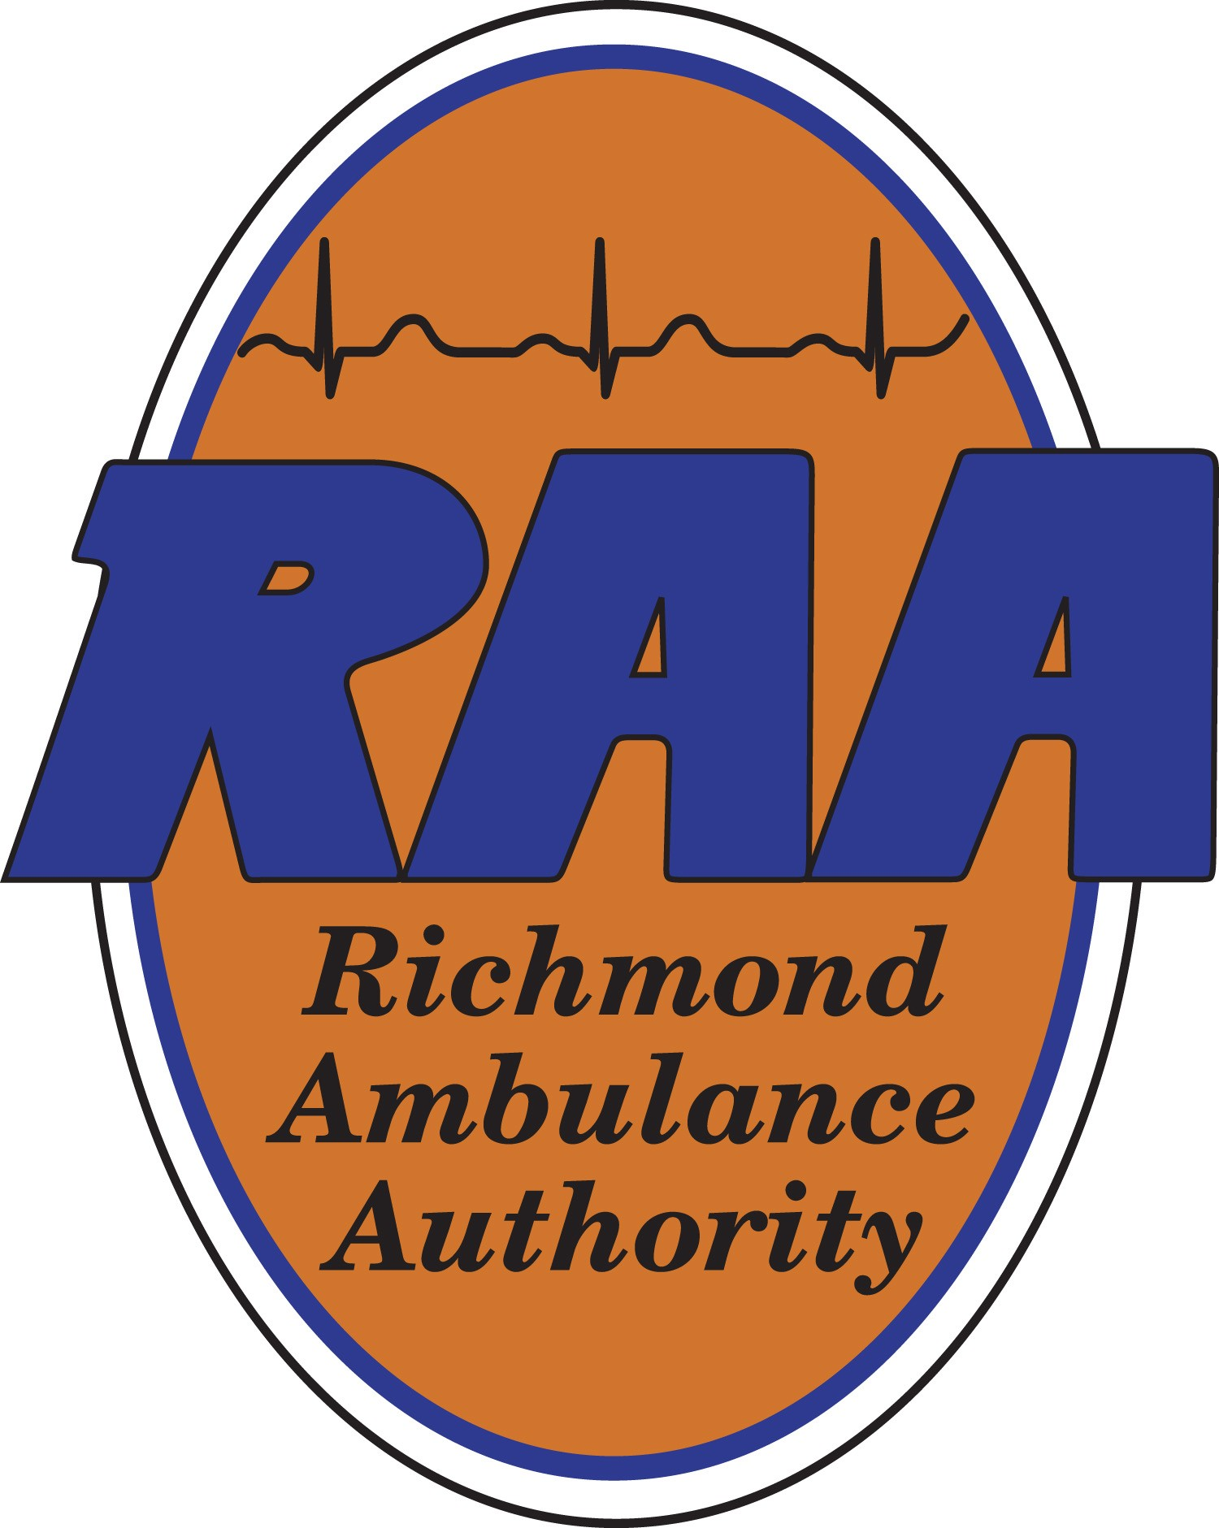

NOTICE OF MEETING

Meeting: Richmond Ambulance Authority Finance Committee Meeting

When: Monday, September 8, 2025 at 12:00 p.m.

Where: Richmond Ambulance Authority, 2400 Hermitage Road, Richmond, VA 23220

To listen to the meeting remotely:

Microsoft Teams
https://teams.microsoft.com/dl/launcher/launcher.html?url=%2F_%23%2Fl%2Fmeetup-join%2F19%3Ameeting_Y2I0ZjY5ZTgtNWI4Yy00ODI4LWFkNDktYTczNjYyYjU5NmM1%40thread.v2%2F0%3Fcontext%3D%257b%2522Tid%2522%253a%252246faa1d8-f1dd-4c09-9284-e445c16a469e%2522%252c%2522Oid%2522%253a%25227e591dee-7213-4115-a633-ed2c3561f315%2522%257d%26anon%3Dtrue&type=meetup-join&deeplinkId=e92f62c0-fb0c-47f1-b819-4595a5c07df2&directDl=true&msLaunch=true&enableMobilePage=true&suppressPrompt=true

Meeting ID: 228 696 825 287 5
Passcode: LC3Bg6fA

