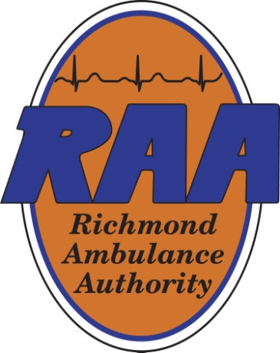 | Finance Committee  September 8, 2025  12:00 pm  RAA Boardroom
Committee Chair: | Kirk Roberts
Committee Members: | Weet Baldwin, Mark Hickman, Carlos Hopkins and Joseph Trapani
Staff Members: | Chip Decker, Chief Executive Officer; Terone Green, Chief Administrative Officer; Wanda Thomas, Director of Reimbursement; and Bryan Aud, Director of Finance (Committee contact: baud@raaems.org or 804-254-1152)
Guest(s): | None
 | Agenda topics
- Call to Order
- Conference Call Attendee(s) – If Applicable
- Reading and approval of the minutes from the previous meeting (5/7/25)
- Review of the FY2025 June Financial Statements - emailed
- Review of the FY2026 July Financial Statements – emailed
- Missing City Subsidy Update
- Other Updates and Discussions
- Adjournment

Minutes from the May 7, 2025 meeting:
In attendance: Kirk Roberts, Weet Baldwin, Mark Hickman, and Sheila White; Not in attendance: Carlos Hopkins; Other Board Members: None; Staff Members: Chip Decker, Terone Green, Wanda Thomas and Bryan Aud; Guests: None
Agenda Topics:
- Approval to meet via Electronic Means – All-Virtual Meeting
- The minutes of the previous meeting (3/11/25) were approved.
- The FY2025 March Financials were reviewed with Committee approval.
- The FY 2026 Final Draft for Adoption Budget (Pages 1 & 2) were reviewed and recommended to the full RAA Board.
- The meeting was adjourned.

Since the last meeting:
New Board member Joseph Trapani has joined the Finance Committee. The FY2025 April and May Financial Statements were emailed to all Committee Members.

